Project Name: Automating CI/CD Pipeline for Spring Boot Application Deployment on AWS
Objective: To implement a CI/CD pipeline using AWS services for automating the deployment of a Spring Boot application on Amazon ECS with Docker, integrating CodePipeline, CodeBuild and ECR for seamless updates

Problem Statement: Imagine a retail company that has a Spring Boot-based inventory management system. The system is used by several departments and is hosted in containers to ensure scalability. The company wants to reduce the manual intervention required to deploy updates by automating the build and deployment process. By setting up a CI/CD pipeline, developers can push updates to a GitHub repository, automatically triggering a sequence of actions that build, containerize, and deploy the application without downtime. This ensures faster and more reliable system updates, minimizing operational delays.

Steps:
- will create a cicd pipeline via code pipeline where we will deploy a springboot application on ECS docker containers
- Process:
  - Our code would be picked up
  - it will go to code build where the project will be converted to the war file (single executable file)
  - we execute the dockerfile to create custom image which would be pushed to ecr
  - from there it would be picked by ecs task to deploy the project
AWS Springboot Application Repo: https://github.com/pradeepviswa/aws-devops-springbootapp
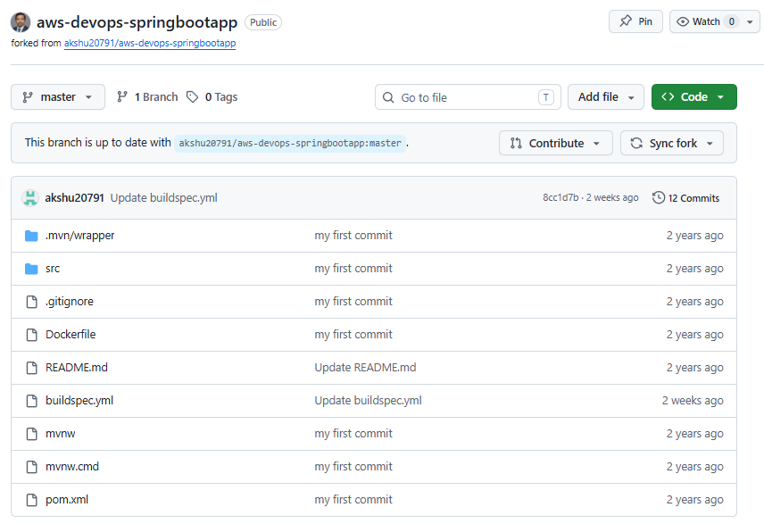

- Create ECR
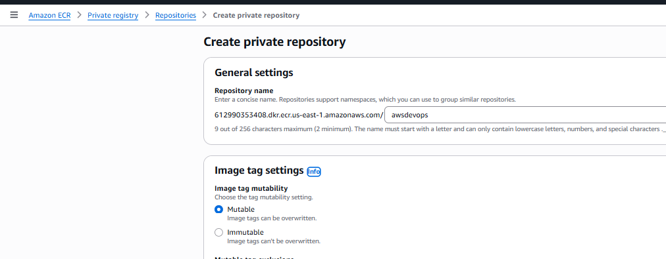

- View push commands and copy command under “Retrieve an authentication token and authenticate your Docker client to your registry. Use the AWS CLI:”
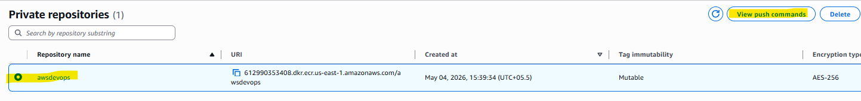
Command: aws ecr get-login-password --region us-east-1 | docker login --username AWS --password-stdin 612990353408.dkr.ecr.us-east-1.amazonaws.com
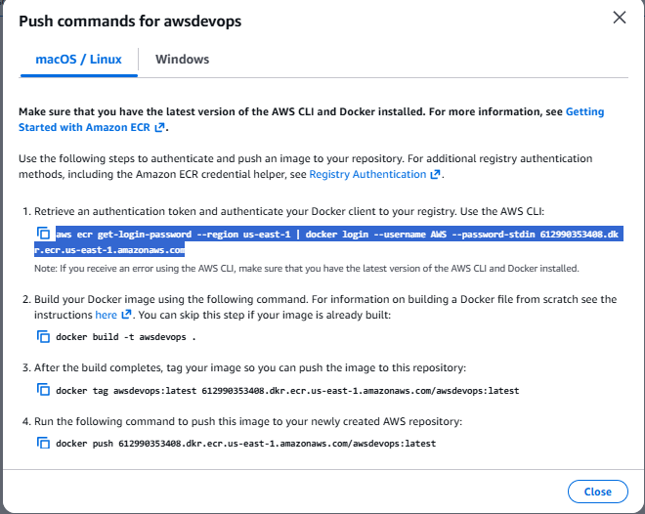

- Go to github repo: https://github.com/pradeepviswa/aws-devops-springbootapp.git
Click on buildspec.yml -> edit the file (by clicking in pencil icon)
Update line no 10 with the code copied above
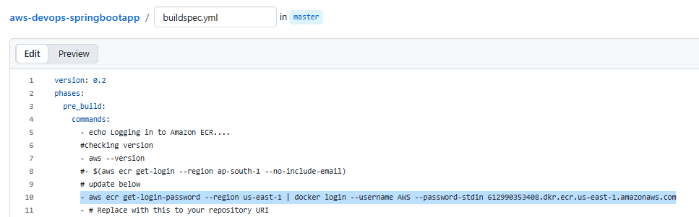

- Go back to ECR and copy ECR Image URI
URI: 612990353408.dkr.ecr.us-east-1.amazonaws.com/awsdevops
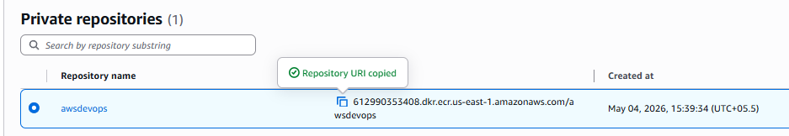

- Paste in buildspec.yml file in github account
On line 12 of buildspec.yml file.
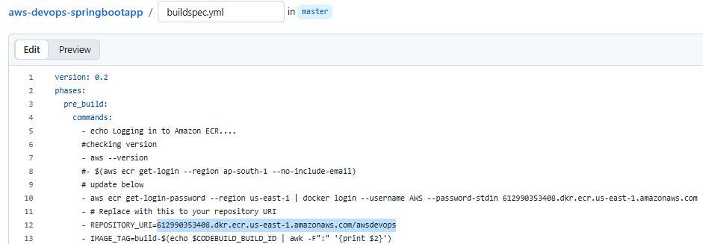
- Build Commands in buildspec.yml file
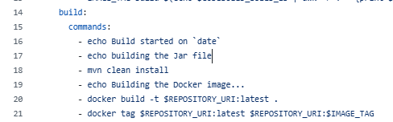
- Now go to code build and create a code build project
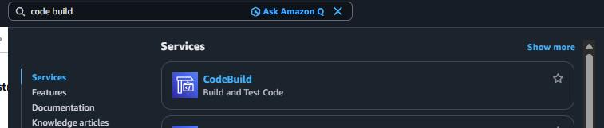
- Create project
Name: AwsDevopsProject
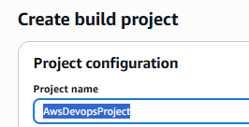
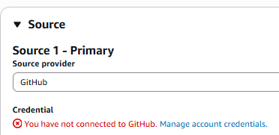
- Click on manage default source credentials
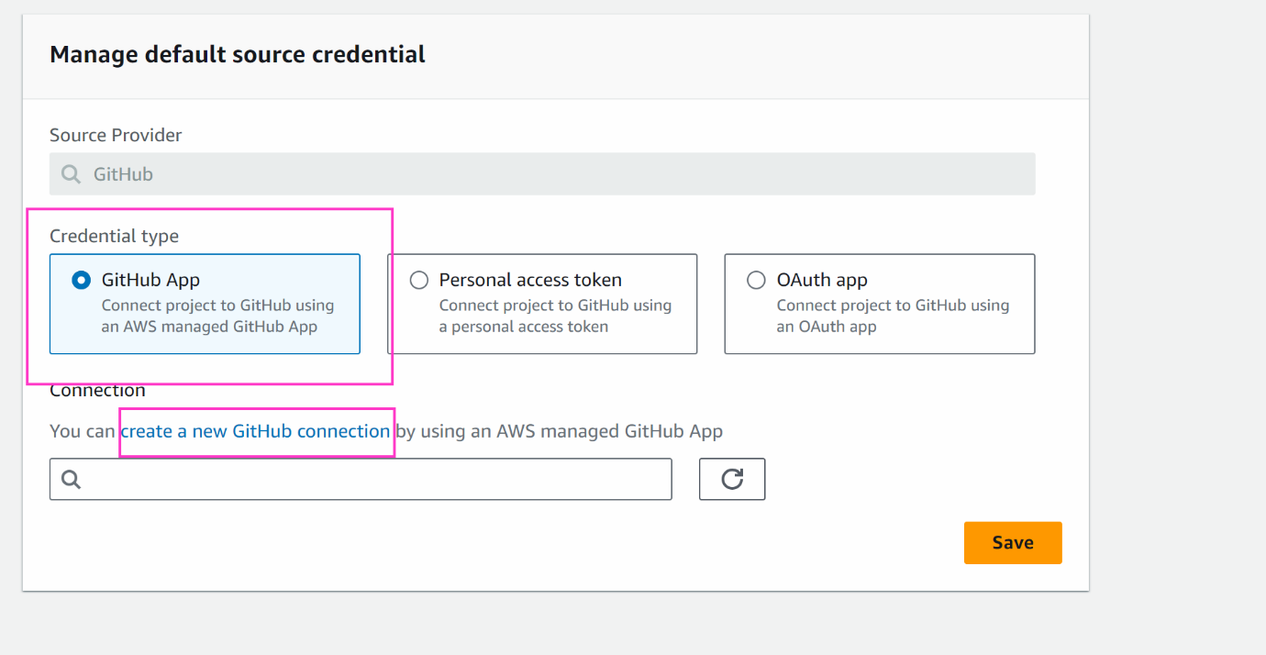

- A pop up will open
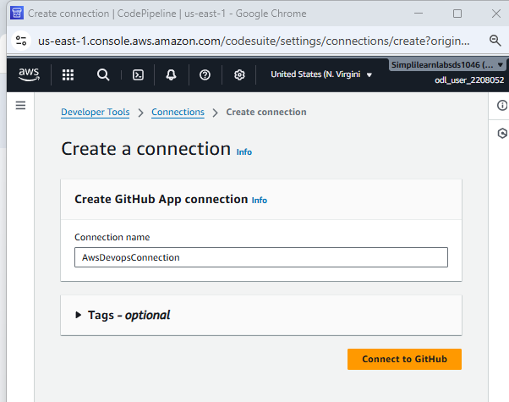
- Install a new app
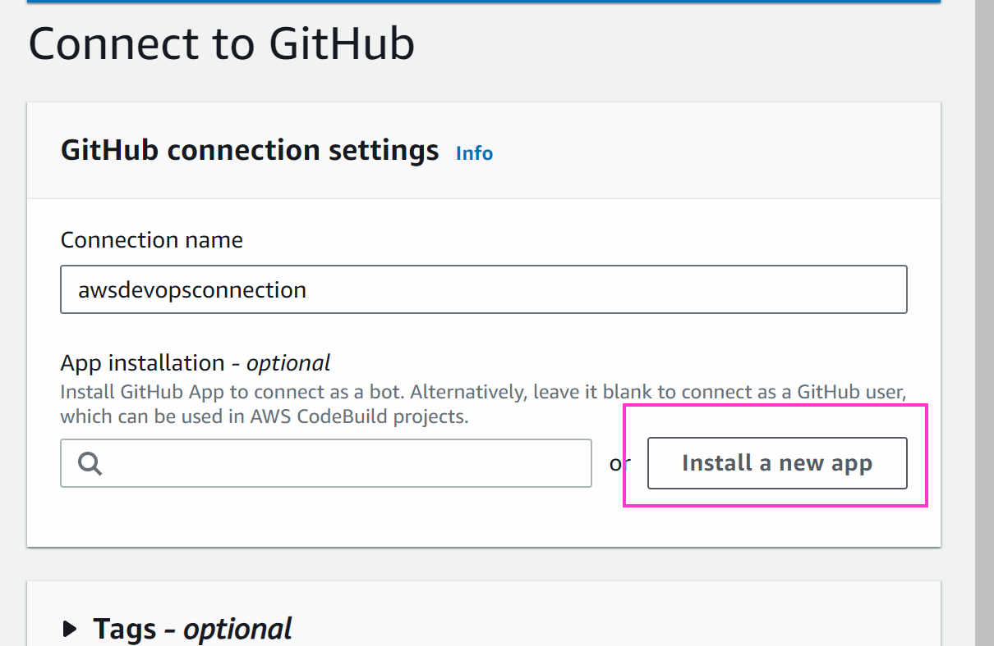

- Select repository then click on Install & Authorize button
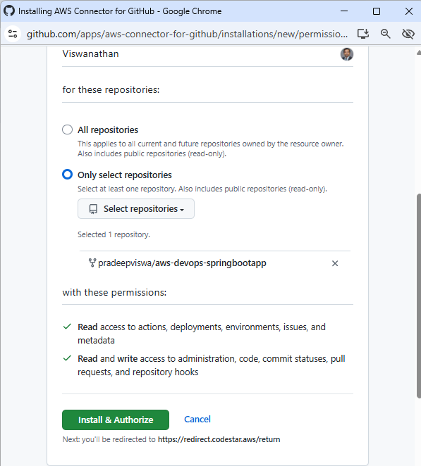

- Authorize
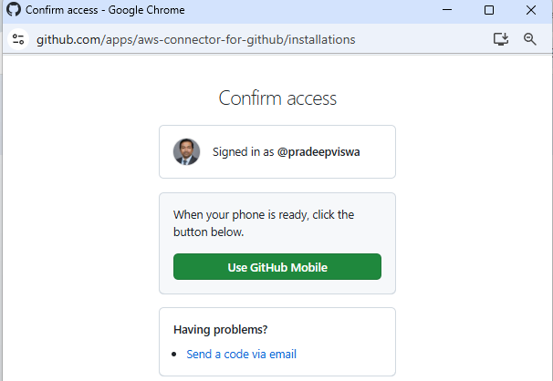
- Connect
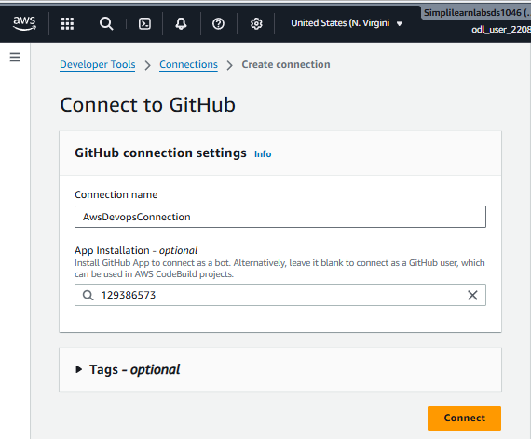
- Select newly created connection and save
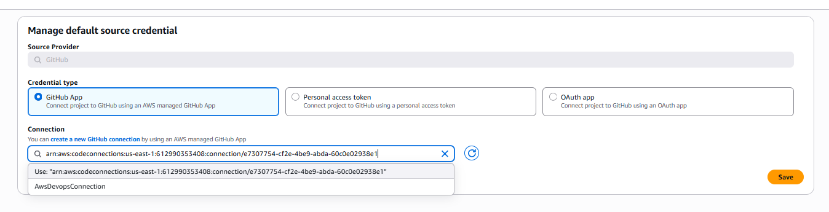
- We get below message in “Create build project” screen and select repository
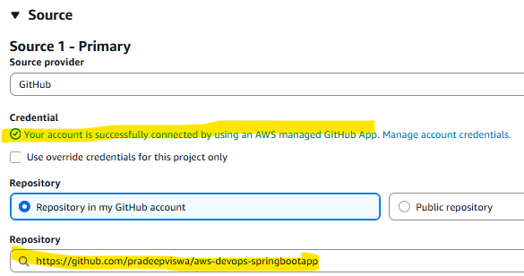
- Let everything be default and scroll down to service role. Remember this role name as we will have to set permission
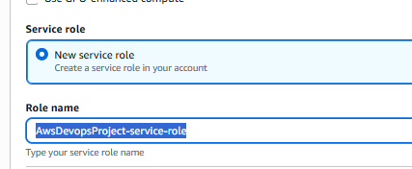
- Set Buildspec file
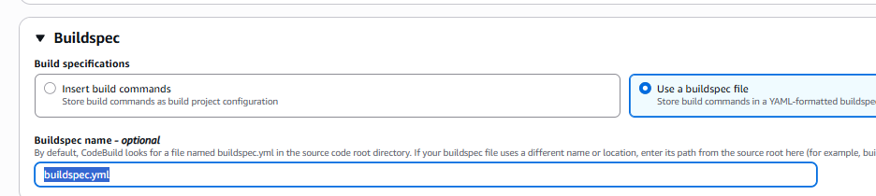
- Click on Create build project
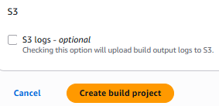
- Project created
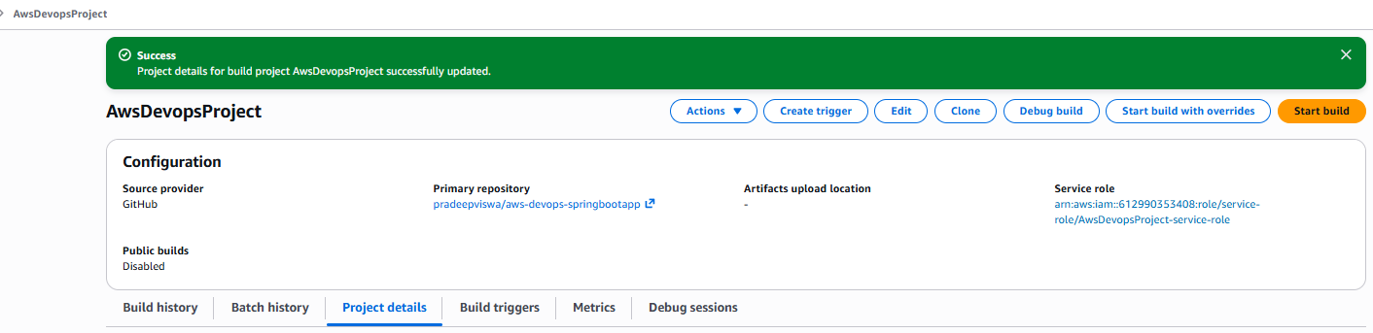
- Go to iam -> roles -> select the role which created while create aws code build:.
click on: AwsDevopsProject-service-role
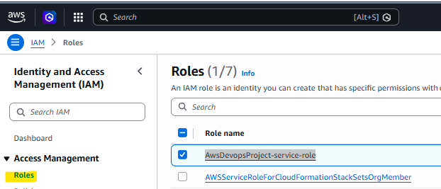
- Add Permission > attach policy
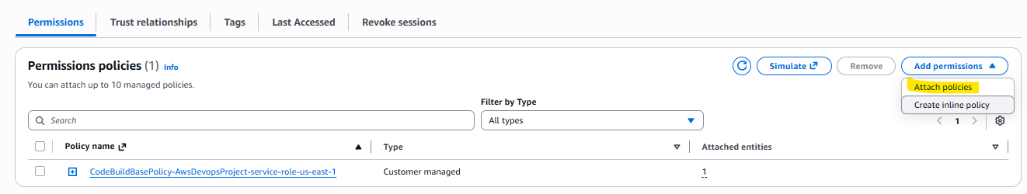
- And below 3 access and click on “Add Permission”
  - Administrator Access
  - AmazonEC2ContainerRegistryFullAccess
  - AmazonEC2ContainerRegistryPowerUser
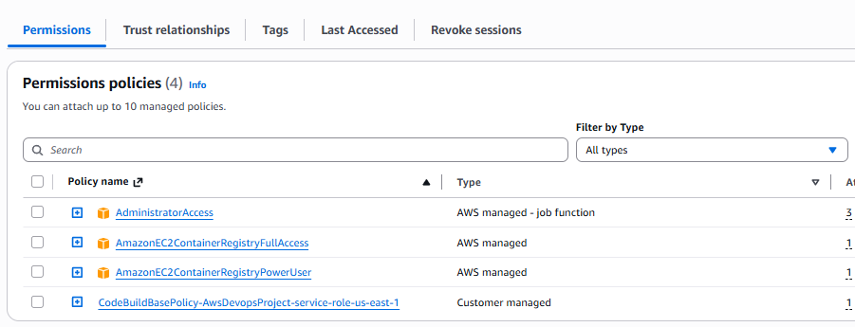
- Now go back to Build Projects: “AwsDevopsProject” and click on “Start Build” button
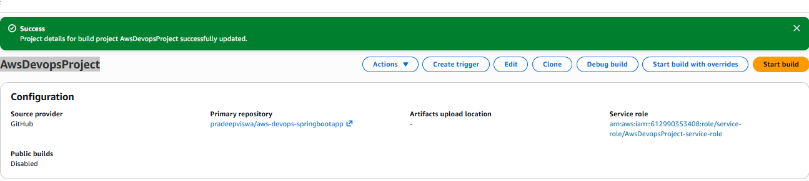
- Build Success
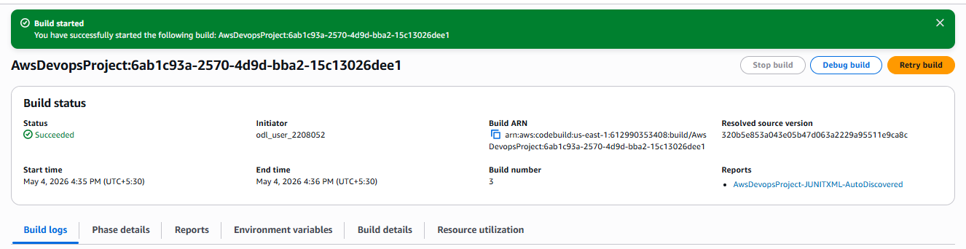
- Now we want to deploy the project, but we need to create ECS tasks and service.
Go to ecs -> create ecs
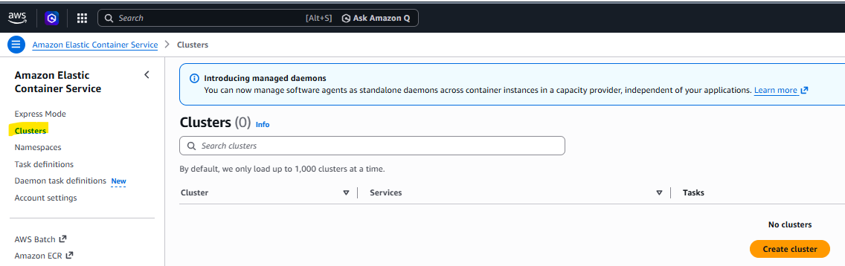
- Cluster Name: AwsDevopsCluster-pv
Default namespace: AwsDevopsCluster-pv
Infrastructure: Fargate4 only
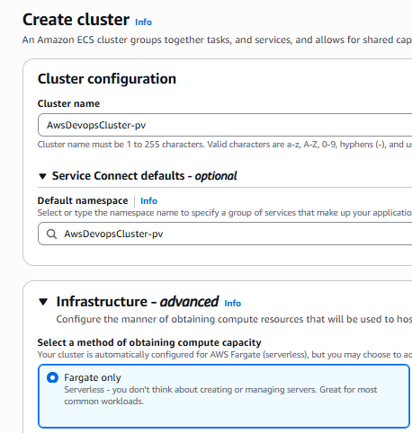
- Cluster created
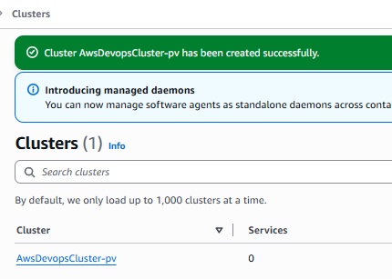
- Click on Task definitions > create new task definition
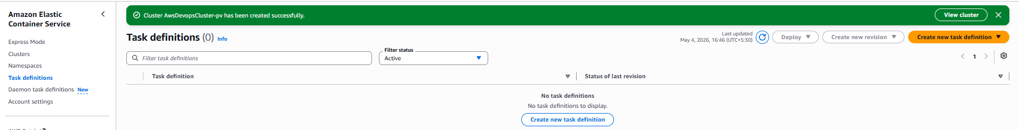
- Task definition name: AwsDevopsTaskDefinition
Infrastructure: Fargate
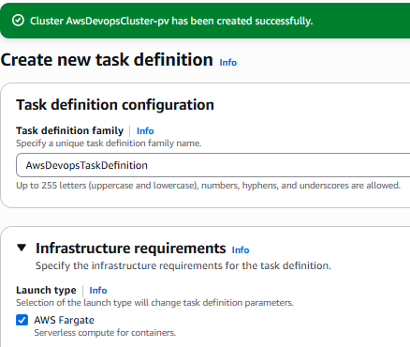

- Scroll down and keep the name of the container as spring-demo-ecr otherwise we need to change the name of the container from the buildspec.yml line number 29
container name: spring-demo-ecr
Image URI: 612990353408.dkr.ecr.us-east-1.amazonaws.com/awsdevops
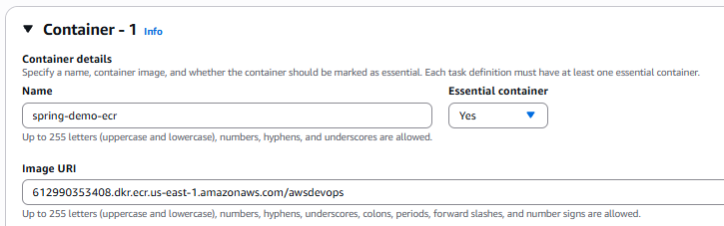
- Set Port mapping as below and click on create:
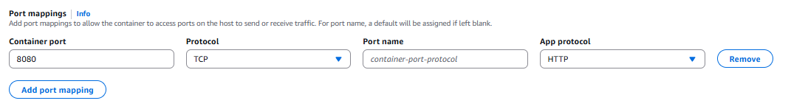
- Create
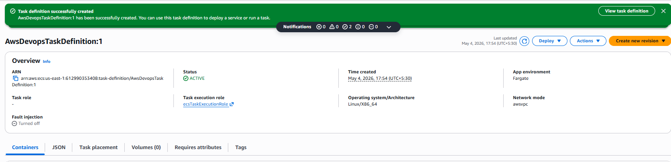
- Go back to the cluster and click on the cluster
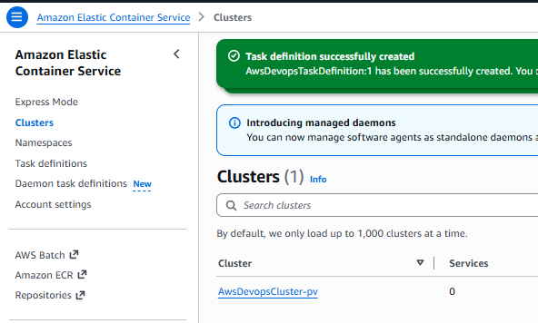

- GO TO ECS -> CLUSTER -> CLICK ON THE CLUSTER WE CREATD
will create a service. Click on create
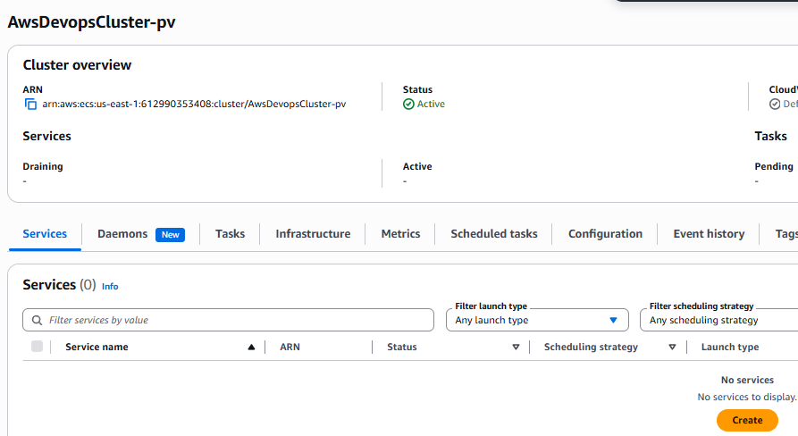

- Select Task definition and Compute configuration as below
keep any service name
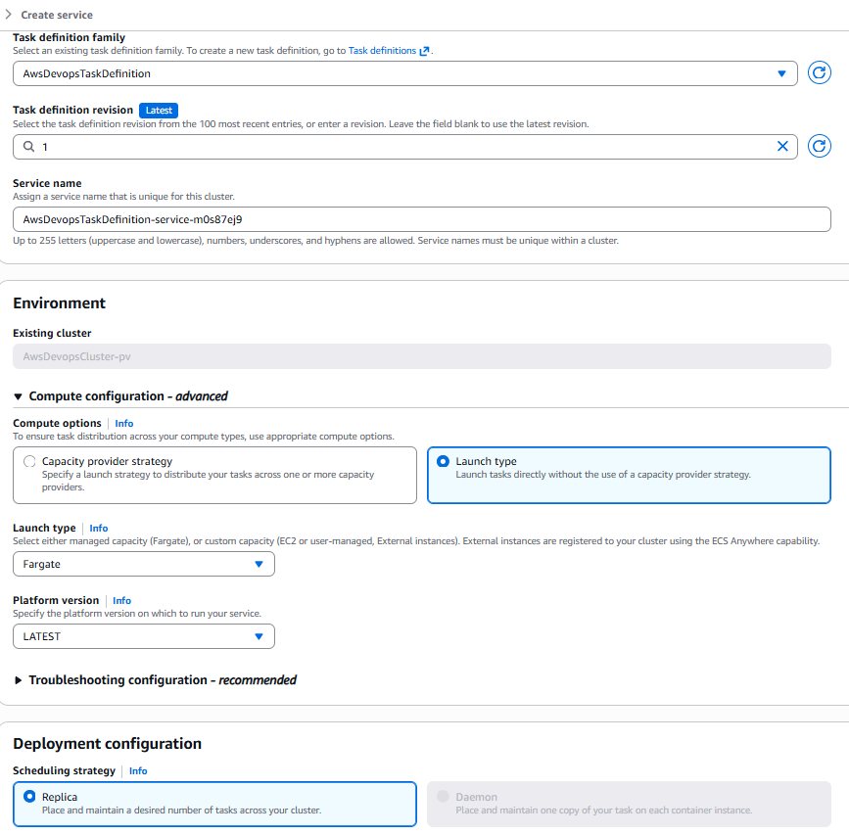

- Service created
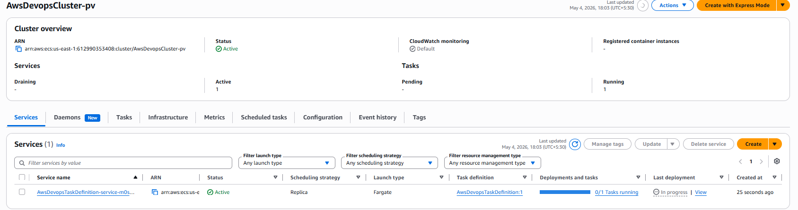

- Task created, click on task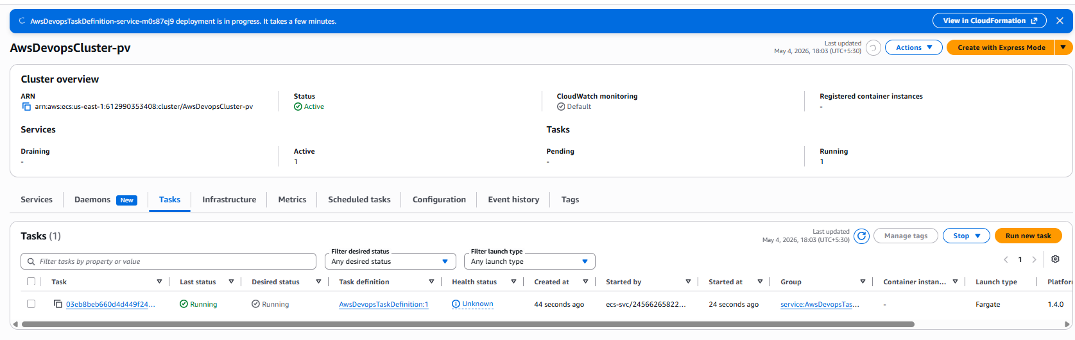
- Copy public ip
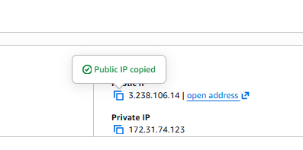
- Open browse and open path like this: http://3.238.106.14:8080/demo/data
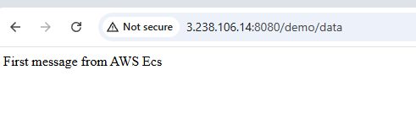
- Now we will build the code pipeline and automate everything in code pipeline
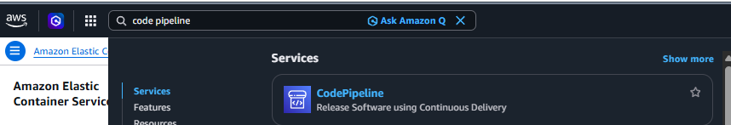
- Click on pipelines > create pipeline
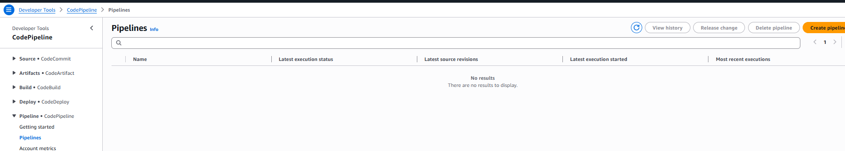
- Build custom pipeline > next
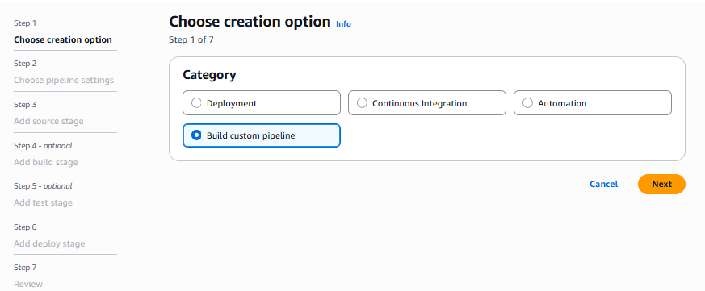
- Pipeline name: AwsDevopsPipeline
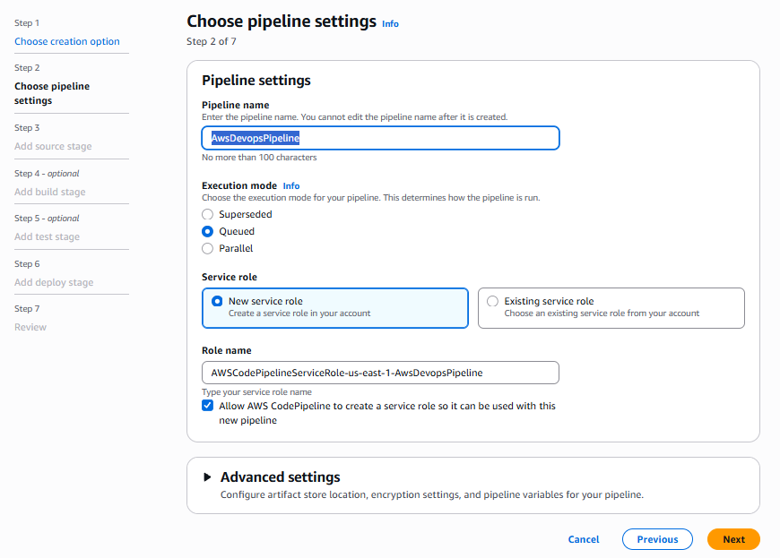

- Source provider: GitHub (via OAuth app)
Connect to github > A popup will appear > Select authorise code suite > Connect
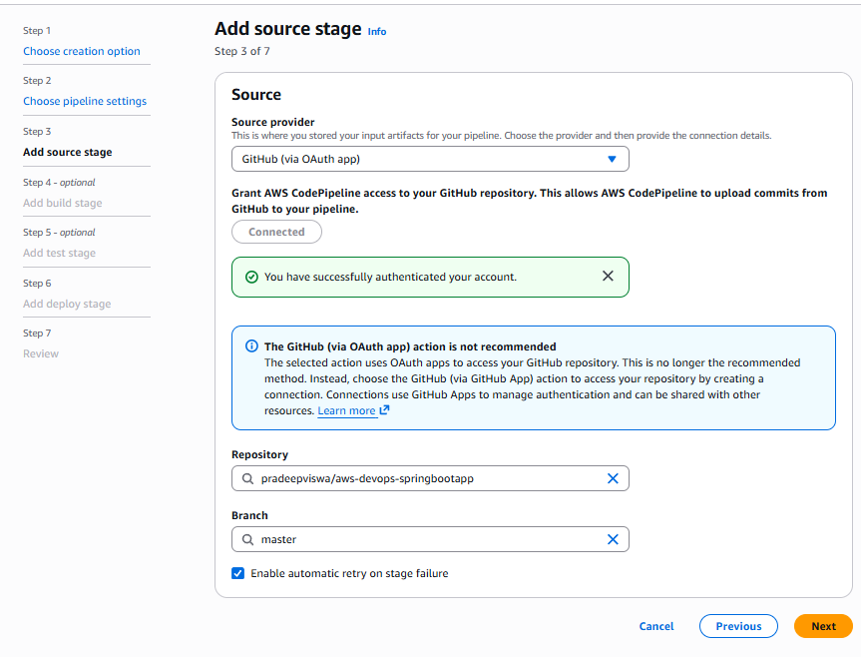

- Click on other build providers
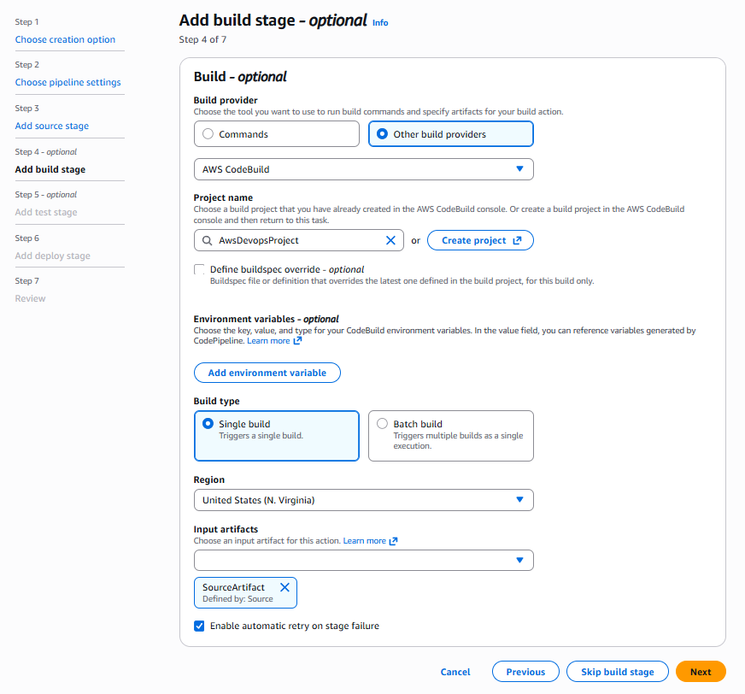
- Step 5
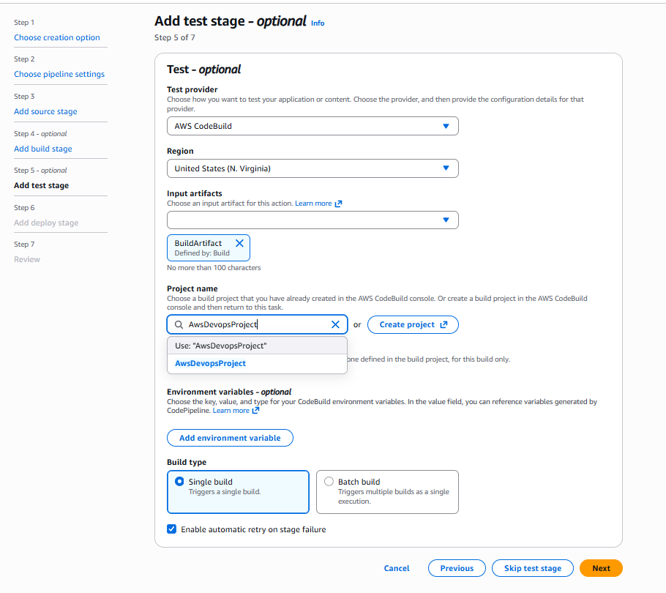
- Step 7
deploy provider: Amazon ECS
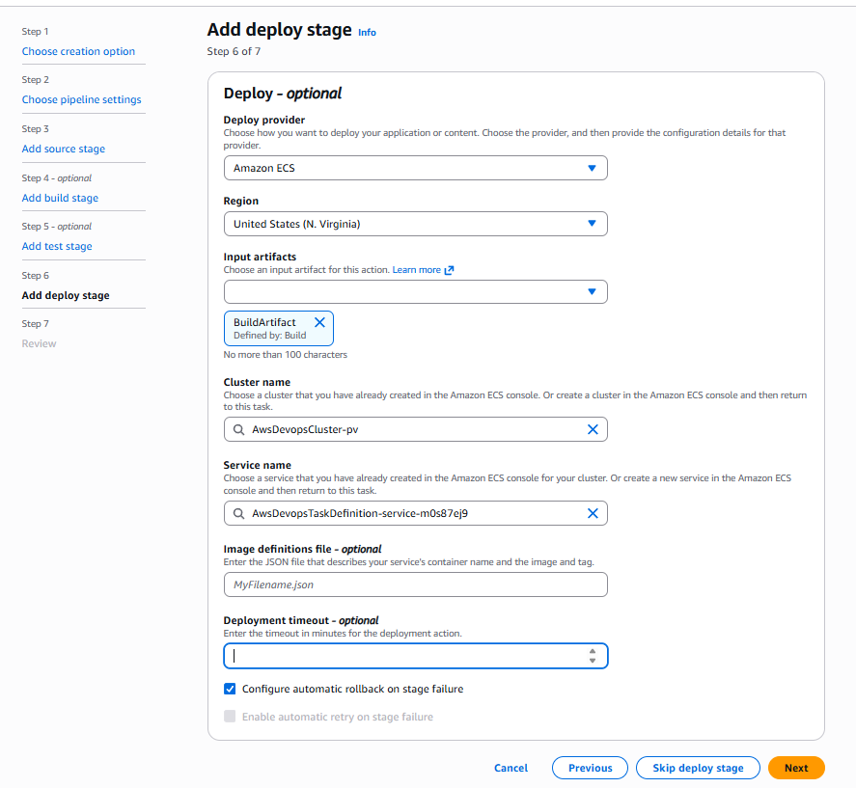
- Create pipeline
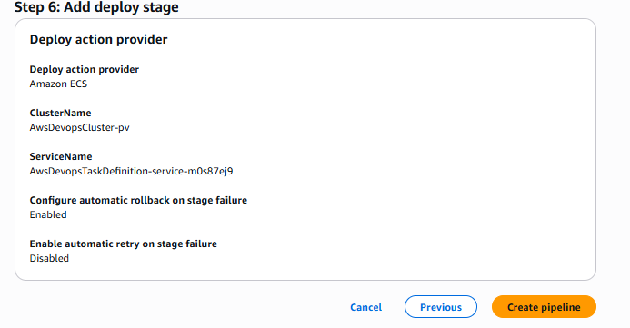
- Pipeline Created, just remove test stage and run the pipeline
